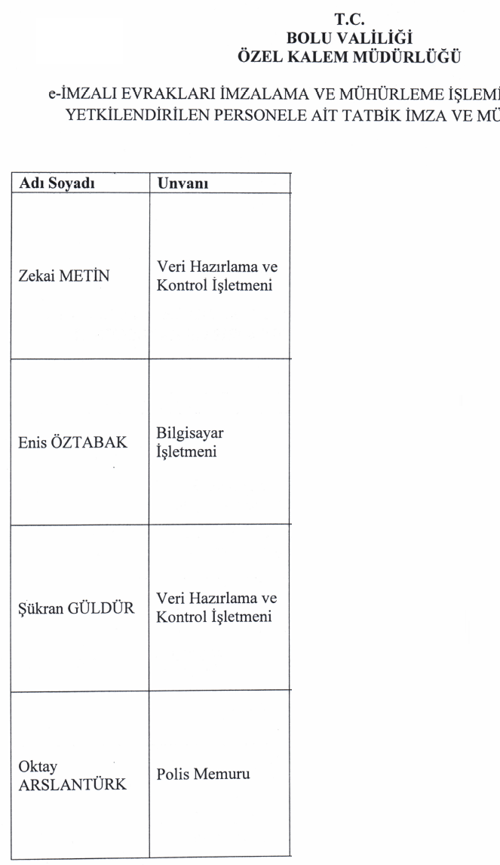



C:\Users\caner.demirel\Desktop\20160413134850802.tif











