**BAYBURT VALİLİĞİ**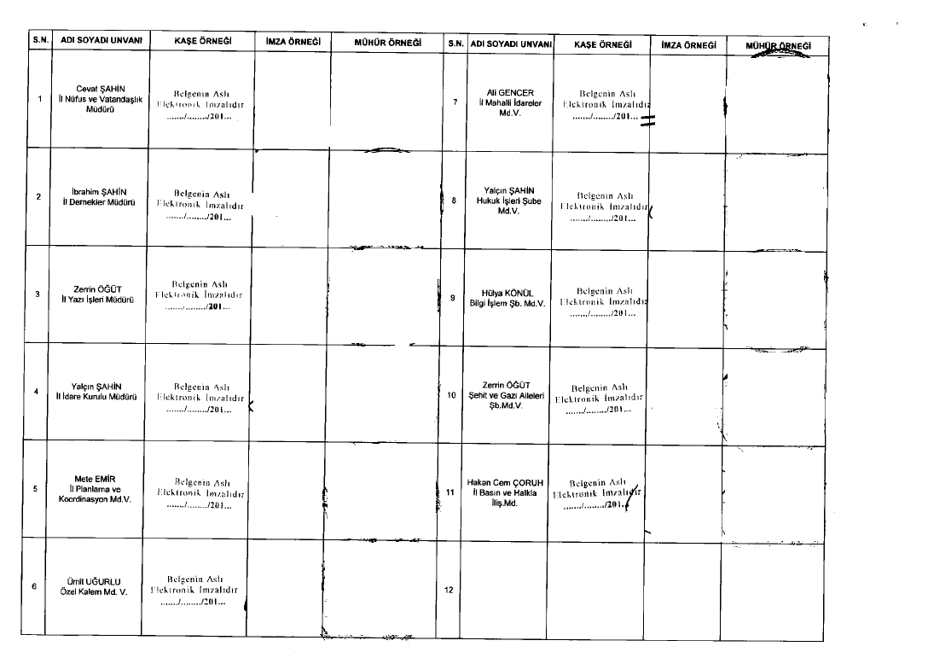

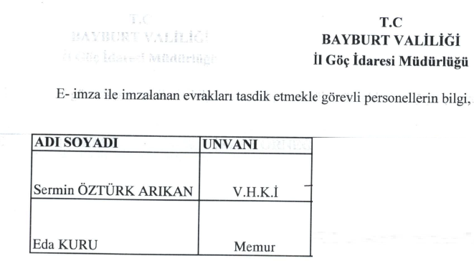

C:\Users\caner.demirel\Desktop\Ä°mza MÃ¼hÃ¼r Ã–rneÄŸi 001.tif







